Teacher Notes for “How do organisms use energy?”

This analysis and discussion activity introduces students to the basic principles of how organisms use energy. The focus is on understanding the roles of ATP, cellular respiration, and hydrolysis of ATP. In addition, students apply the principles of conservation of energy and conservation of matter to avoid common errors and correct common misconceptions.

Table of Contents
Learning Goals – pages 1-2
Instructional Suggestions and Background Information
General – pages 2-3
Introduction – pages 3-5
Cellular respiration makes ATP. – pages 5-8
Using ATP to Provide Energy for Biological Processes – pages 8-11
Sources for Student Handout Figures and Follow-Up Activities – page 11

Learning Goals
In accord with the Next Generation Science Standards, this activity:
- helps students to learn the Disciplinary Core Idea LS1.C: " Cellular respiration is a chemical process whereby the bonds of food molecules and oxygen molecules are broken”, carbon dioxide and water are formed, and the energy released is used to produce ATP from ADP and P. The hydrolysis of ATP molecules provides the energy needed for many biological processes.
- engages students in the recommended Scientific Practice, "Constructing Explanations: Apply scientific ideas, principles, and/or evidence to provide an explanation of phenomena…"
- can be used to illustrate the Crosscutting Concept "Energy and matter: Flows, cycles and conservation", including
- “Energy cannot be created or destroyed – only moves between one place and another place, between objects and/or fields, or between systems.”
- “Matter is conserved because atoms are conserved in physical and chemical processes.”
- helps students to prepare for Performance Expectation HS-LS1-7, "Use a model to illustrate that cellular respiration is a chemical process whereby the bonds of food molecules and oxygen molecules are broken and the bonds in new compounds are formed resulting in a net transfer of energy."

Additional Content Learning Goals
- Cells use cellular respiration and hydrolysis of ATP to provide the energy needed for many biological processes.
- In cellular respiration, sugars (or other small organic molecules) and oxygen are the inputs for reactions that provide the energy to make ATP from ADP plus a phosphate (P).
- The hydrolysis of ATP provides the energy needed for many biological processes (e.g. synthesizing biological molecules and mechanical work).
- The hydrolysis of ATP produces ADP and P, which cellular respiration uses to make ATP.
- The following pair of coupled chemical reactions summarizes the cellular respiration of glucose:
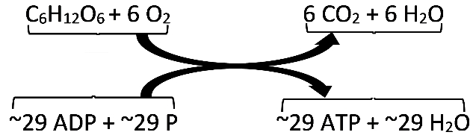
- Energy can be transformed from one type to another, but energy cannot be created or destroyed by biological processes. All types of energy transformation are inefficient and result in the transformation of some energy to thermal energy.

Instructional Suggestions and Background Information
To maximize student participation and learning, I suggest that you have your students work in pairs (or individually or in small groups) to complete groups of related questions and then have a class discussion after each group of related questions. In each discussion, you can probe student thinking and help them to develop a sound understanding of the concepts and information covered before moving on to the next group of related questions.

If your students are learning online, I recommend that they use the Google Doc version of the Student Handout available at https://serendipstudio.org/exchange/bioactivities/energy. To answer questions 3 and 4, students can either print the relevant page, draw on it and send pictures to you, or they will need to know how to modify a drawing online. To answer online, they can double-click on the relevant drawing in the Google Doc to open a drawing window. Then, they can use the editing tools to answer the questions.

You can prepare a revised version of the Student Handout, using the Word document. If you use the Word document, please check the format by viewing the PDF.

A key is available upon request to Ingrid Waldron (iwaldron@upenn.edu). The following paragraphs provide additional instructional suggestions and background information – some for inclusion in your class discussions and some to provide you with relevant background that may be useful for your understanding and/or for responding to student questions.

If your students are not familiar with cellular respiration, you may want to precede this activity with the animal unit from Carbon TIME – Transformations in Matter and Energy (https://carbontime.create4stem.msu.edu/animals). These hands-on activities can provide a context for the more abstract presentation in this “How do organisms use energy?” activity.

General Background
The Student Handout for this activity does not begin with a definition of energy, primarily because energy is such a difficult concept to define. Instead, this activity assumes a naive concept of energy and builds a more sophisticated understanding through the explanations and questions in the Student Handout.

If you prefer to begin with a definition of energy, you can use the following information. Energy can be thought of as a property or characteristic of things that can make something happen (https://www.ftexploring.com/energy/definition.html; https://www.nmsolar.org/energy-101/). Although this definition is unsatisfactorily vague, energy is nevertheless a valuable concept because of the important principles related to energy which help us predict and understand multiple scientific and real-world phenomena. These important principles include:
- Energy can be transformed from one type to another (e.g. chemical energy stored in ATP can be converted to the kinetic energy of muscle contraction), but all energy is fundamentally the same.
- Energy is not created or destroyed (in biological processes). In other words, energy lasts forever. This conservation of energy principle is the First Law of Thermodynamics.
- Every energy transformation is inefficient; i.e. some of the energy is converted to thermal energy. This principle is one implication of the Second Law of Thermodynamics.

Important points that are not explicitly presented in the Student Handout are:
- Chemical bonds result from an attraction between the bonded atoms, so it requires energy input to separate the atoms and break a chemical bond. Conversely, the formation of a chemical bond releases energy.
- A chemical reaction releases energy when the bonds that are formed are more stable than the bonds that are broken.
- Because energy can only be released when molecules react to form other molecules, it is more accurate to think of energy as stored in a system (e.g. a system of reactants), rather than in individual molecules or bonds.
These points are not explicitly included in the Student Handout because they represent a relatively sophisticated understanding which is not common in textbooks or in the training of teachers. However, the wording of the Student Handout is compatible with these principles. For additional information, please see “Cellular Respiration and Photosynthesis – Important Concepts, Common Misconceptions, and Learning Activities” (https://serendipstudio.org/exchange/bioactivities/cellrespiration).

Introduction
Question 1 is intended to provide a familiar context for the molecular approach in most of the Student Handout. In response to question 1a, students should easily answer that our bodies need energy for physical activity. With questioning, they should be able to think of other reasons we need energy, e.g. for heart and brain activity and for cellular processes such as synthesizing molecules or pumping ions in and out of the cell. An adult who is not growing needs to eat food that contains molecules that can be metabolized to provide energy for these processes (question 1b). Also, our bodies need to replace damaged molecules (e.g. proteins), so our bodies need a supply of molecules that can be used to synthesize replacements (e.g. amino acids).

Page 1 of the Student Handout states that “your cells use glucose and other small organic molecules to make ATP.” In this context, “other small organic molecules” refers to fatty acids, glycerol and amino acids, which can be used for cellular respiration. Obviously, the organic molecules ATP and ADP are not included here.

You may want to reinforce student understanding that the D in ADP stands for “di” and that T in ATP stands for “tri”. To further help students understand the name adenosine triphosphate, you may want to show them the figure below.

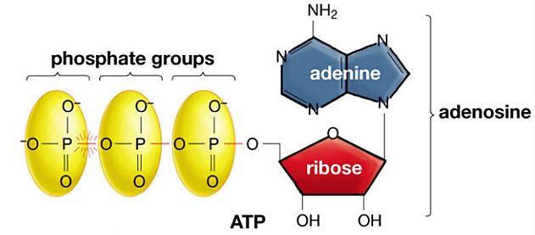

Students may inquire about where ADP comes from. Nucleotides like ADP are derived from digestion of nucleic acids in food and also can be synthesized from precursors.

Question 2 focuses on the need for energy to bring together the negatively charged ADP and P. For more complete explanations of the reasons why energy input is required to make ATP from ADP + P, see “Metabolism Is Composed of Many Coupled, Interconnecting Reactions” (https://www.ncbi.nlm.nih.gov/books/NBK22439/) and "Phosphate Group Transfers and ATP” (http://www.bioinfo.org.cn/book/biochemistry/chapt13/bio3.htm).

Your students may find the following analogy between ATP and money helpful.

Notice that the role of ATP in biological organisms is somewhat similar to the role of money in our society. Most adults use a two-step process to get food, clothing, etc.

Cellular respiration of sugars or other organic molecules provides the energy to make ATP. | Many adults work to earn money.
Then, the hydrolysis of ATP provides the  energy for most biological processes. | Then people spend their money to buy the things they need or want.

Question 3a requires students to synthesize what they have learned about how cellular respiration provides the energy to make ATP and how the hydrolysis of ATP provides energy for biological processes. Students may find the analogy to a rechargeable battery useful. | 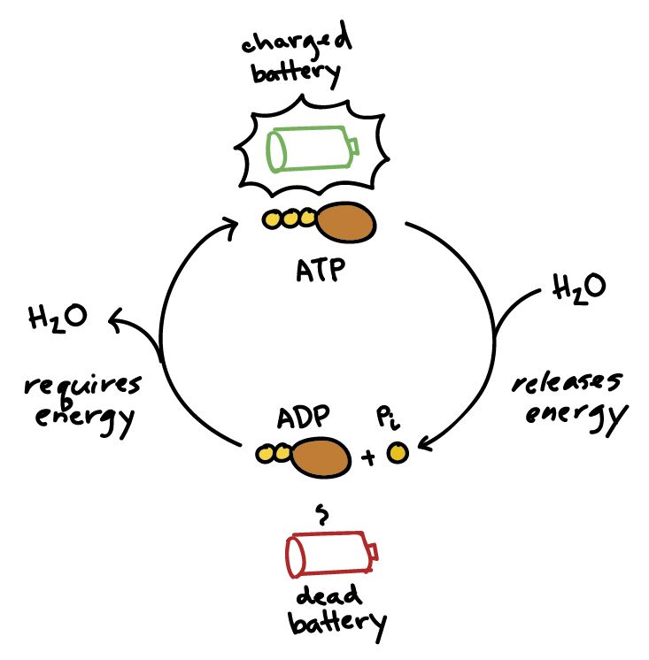  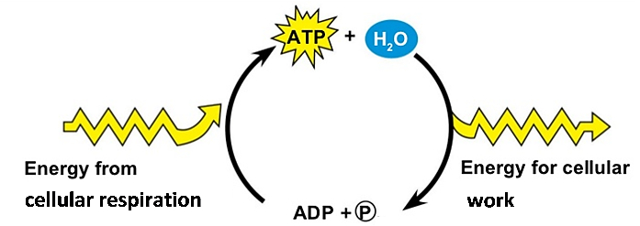

Question 3b helps students to understand that cells are dynamic systems with constant molecular activity. Our cells are constantly carrying out cellular respiration to make ATP and using ATP to provide the energy for biological processes such as synthesizing molecules and pumping ions and molecules into and out of cells. On average, each ATP molecule in our body is used and re-synthesized more than 30 times per minute when we are at rest and more than 500 times per minute during strenuous exercise. A very large number of ATP molecules are used for some processes; for example, one study has found that ~10⁵ ATP are used for a single beat of a sperm flagellum.

Cellular respiration makes ATP.
The coupled equations shown in the middle of page 2 of the Student Handout indicate that cellular respiration generates ~29 molecules of ATP for each glucose molecule; this number is less than previously believed (and often erroneously stated in textbooks). This revised estimate is based on recently discovered inefficiencies and complexities in the function of the electron transport chain and ATP synthase enzyme. The number of ATP produced per molecule of glucose is variable because of variability in the efficiency of the electron transport chain proton pumps and the ATP synthase. These recent findings are interesting as an example of how science progresses by a series of successively more accurate approximations to the truth.

As you discuss coupled reactions, you may want to introduce the general concept of energy-releasing reactions (exergonic or exothermic reactions) and energy-consuming reactions (endergonic or endothermic reactions).

In discussing question 5, it should be mentioned that we need to breathe not only to bring in O₂, but also to get rid of CO₂.

Question 6 provides the opportunity to reinforce student understanding that, for humans and other animals, the organic molecules for cellular respiration ultimately come from food molecules. The immediate source of glucose for cellular respiration may be glycogen (a polymer that stores glucose) or conversion of fats or amino acids to glucose. In addition, fatty acids and amino acids can be used directly in cellular respiration.

Plants get the organic molecules for cellular respiration from photosynthesis. You may want to point out that, although different types of organisms get their energy input from different sources (e.g. food vs. sunlight), all organisms need to make ATP since hydrolysis of ATP provides energy in a form that can be used for many cellular processes. These concepts are reinforced in the analysis and discussion activity, “Photosynthesis and Cellular Respiration – Understanding the Basics of Bioenergetics and Biosynthesis” (https://serendipstudio.org/exchange/bioactivities/photocellrespir).

The chemical equation shown in question 7a seems to imply that there are no molecular precursors for ATP. Students should recognize that this would violate the principle of the conservation of matter. (This important principle will tie in with the conservation of energy, discussed near the end of the activity. You may want to explicitly mention that energy cannot be converted to matter.) If your students are having trouble answering question 7b, you may want to add the hint that the corrected equation should include molecules that will provide the atoms in ATP. Also, there should be some indication that cellular respiration of a single molecule of glucose provides the energy to produce multiple molecules of ATP. Thus, a more accurate version of the equation in question 7a would be:
C₆H₁₂O₆ + 6 O₂ + ~29 ADP + ~29 P 6 CO₂ + 6 H₂O + ~29 ATP + ~29 H₂O

You may want to point out to your students the multiple ways that cellular respiration is represented, as shown in the table below. If you want, you can use this table to have students analyze the similarities and differences between these different representations of cellular respiration. For example, you could ask your students to identify ADP and ATP in each representation; you could also ask them what additional information is shown in the first representation or the last two representations that is not shown in the other representations.

Different Representations of Overview of Cellular Respiration | Source
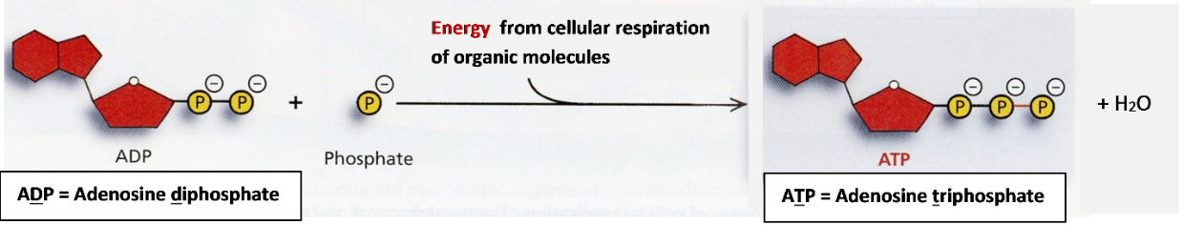 | Page 1 of Student Handout
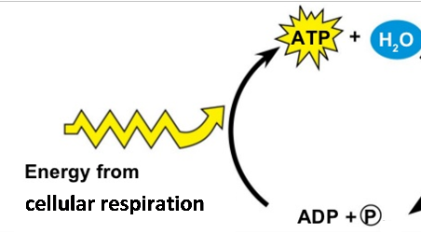 | Part of answer to question 3a
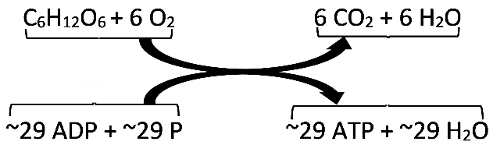 | Page 2 of Student Handout
C₆H₁₂O₆ + 6 O₂ + ~29 ADP + ~29 P 6 CO₂ + 6 H₂O + ~29 ATP + ~29 H₂O | Answer to question 7b.

The representations of cellular respiration provided in this activity give a very simplified overview of a complex process. The figure below summarizes the multiple steps of
cellular respiration, although it omits many of the specific steps. Notice that the oxidation of glucose is coupled with the production of ATP by a complex sequence of processes, including the electron transport chain which pumps protons into the intermembrane space; the resulting differential in proton concentration provides the energy for the enzyme ATP synthase to produce ATP. These processes are analyzed in the advanced version of “Using Models to Understand Cellular Respiration” (https://serendipstudio.org/exchange/bioactivities/modelCR).
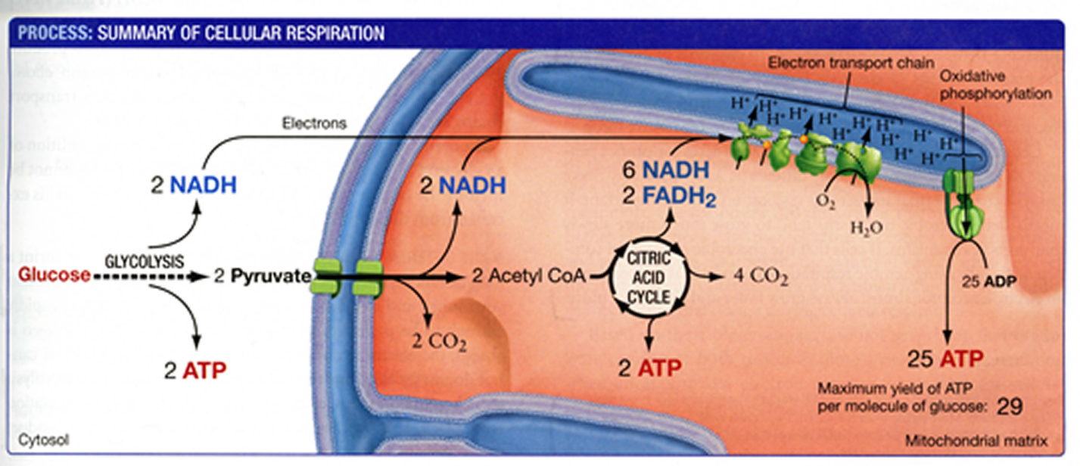(From "Biological Science" by Scott Freeman, Benjamin Cummings, 2011)
Intermembrane space

Aerobic cellular respiration is not the only process cells use to make ATP. Our muscle cells, yeast cells, and other cells in other organisms can use fermentation which includes glycolysis, but not the processes in mitochondria, which require oxygen. As would be expected, fermentation yields much less ATP per glucose molecule than aerobic respiration.

Using ATP to Provide Energy for Biological Processes
The hydrolysis of ATP is shown in the figure below. As you know, hydrolysis refers to a chemical reaction in which a molecule is split into smaller molecules by reacting with water.

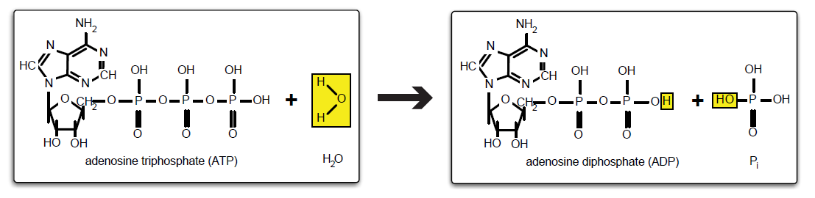
(http://umdberg.pbworks.com/w/page/79788248/ATP%20hydrolysis)

The top of page 3 of the Student Handout summarizes how ATP is used to provide the energy for muscle contraction. The figures below give additional information.

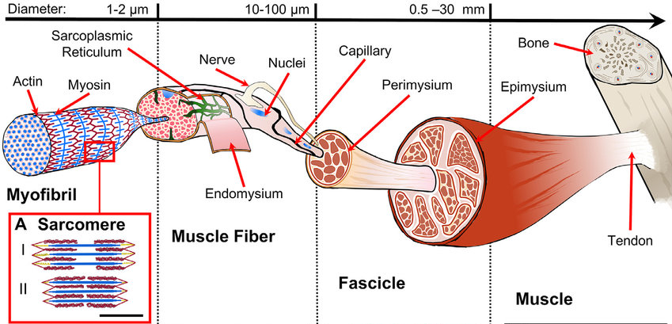
(https://www.researchgate.net/profile/Alberto-Sensini/publication/343590590/figure/fig1/AS:923518707462146@1597195426607/Hierarchical-structure-of-skeletal-muscle-A-Sarcomere-morphology-and-sliding-mechanism.jpg)

A muscle contracts when the sarcomeres shorten. The figure below shows the molecular mechanism by which sarcomeres shorten. Notice that the hydrolysis of ATP occurs after the ATP is bound to the myosin molecule (4 –> 1 in the figure below).

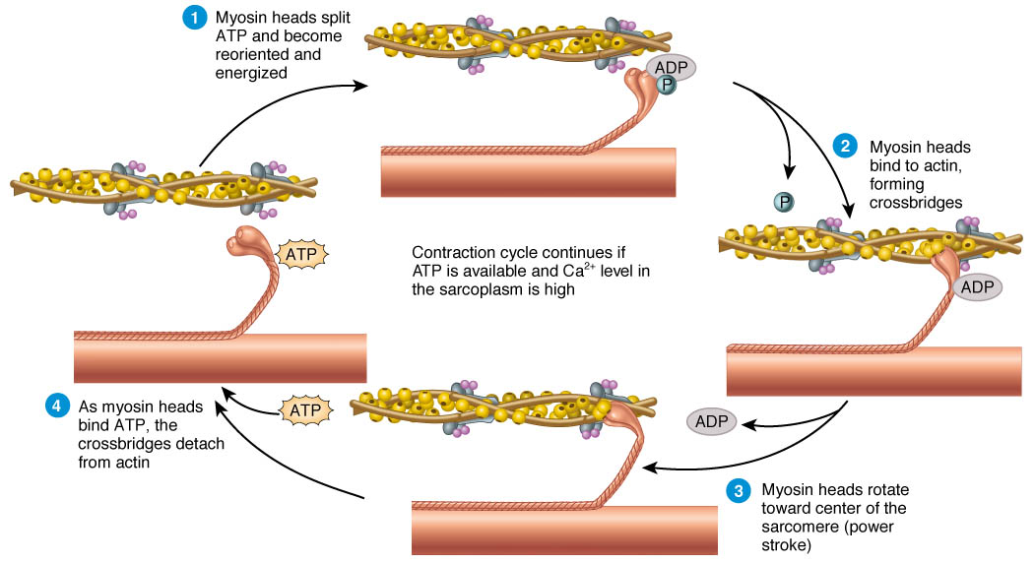
(https://images.ctfassets.net/4yflszkpcwkt/3o3TZPk6smJ5Tb5p8Ys6J9/b690a3f6ceb7a16254777912fce6f5b9/sliding-filimang-theory.jpg)

The figure below illustrates how ATP provides the energy for several other cellular processes. First, ATP reacts with a substrate to produce a phosphorylated substrate; then hydrolysis of ATP provides the energy for conformational change (movement) or for an endergonic reaction with another molecule to produce a product. Notice that the energy released by the hydrolysis of ATP is used immediately and is not stored somewhere until needed. 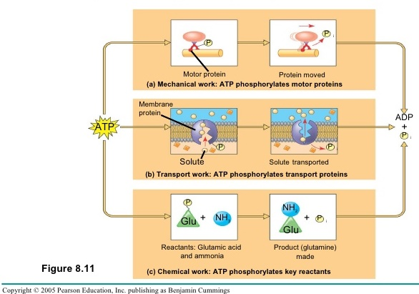
(http://image.slidesharecdn.com/ch8-091101165839-phpapp01/95/forjeffpark-25-728.jpg?cb=1257095688)

You may want to discuss with your students the multiple ways of representing how the hydrolysis of ATP provides the energy for biological processes, including:
- the bottom figure on page 1 of the Student Handout
- the right side of the figure that students complete in question 3a
- the figure on the top of page 3 in the Student Handout.

In responding to question 9, students should realize that all the cells in our body need to continuously carry out the hydrolysis of ATP to provide the energy needed for the processes of life, including synthesizing molecules and pumping ions in and out of the cell.

With regard to the general principles about energy, another example of the inefficiency of energy transfer is that only about 30% of the energy released by cellular respiration of a glucose molecule is captured in the ATP molecules produced, and the rest of the energy becomes thermal energy.

With regard to question 10, the mistake of claiming that mitochondria make energy is widespread even in publications that generally maintain high standards of accuracy. The First Law of Thermodynamics states that energy can be changed from one type to another, but energy is not created or destroyed. In accord with this principle, mitochondria do not make energy. Rather, in cellular respiration, glucose (or another small organic molecule) and oxygen are the inputs for a series of reactions that provide the energy to produce ATP from ADP and P.

Questions 7 and 10 provide the opportunity to reinforce student understanding that they need to read critically and thoughtfully and not just assume that everything that appears on the web or in textbooks is accurate. Of course, high school students do not have the background to judge whether the statements in the Student Handout for this activity are more accurate than the statements in their textbook or on the web, but they can evaluate whether statements are logically consistent with general principles such as conservation of energy and matter.

Sources for Student Handout Figures
- Making and using ATP on page 1 – modified from “Biology – Science for Life with Physiology” by Belk and Borden, 2007 and https://cdn-degmb.nitrocdn.com/ttfRdoaCkYdYriFDAQYzsXWjIyYFFwdP/assets/images/optimized/rev-d26f84f/3dmusclelab.com/wp-content/uploads/2019/02/muscle-contractions.jpg
- ATP – ADP cycle on page 2 – modified from https://slideplayer.com/slide/9403114/28/images/18/ATP+%E2%80%93+ADP+Cycle+H2O+Energy+for+cellular+work+%28endergonic%2C.jpg
- Hydrolysis of ATP on page 3 – modified from http://umdberg.pbworks.com/w/page/79788248/ATP%20hydrolysis

Follow-up Activities
This activity is intended as the first in a series of four introductory activities. The other activities in this introductory sequence are:
- “Using Models to Understand Cellular Respiration” (https://serendipstudio.org/exchange/bioactivities/modelCR)
- “Using Models to Understand Photosynthesis” (https://serendipstudio.org/exchange/bioactivities/modelphoto)
- “Photosynthesis and Cellular Respiration – Understanding the Basics of Bioenergetics and Biosynthesis” (https://serendipstudio.org/exchange/bioactivities/photocellrespir)
or
“Photosynthesis, Cellular Respiration and Plant Growth” (https://serendipstudio.org/sci_edu/waldron/#photobiomass)

Additional follow-up activities and biology background are provided in "Cellular Respiration and Photosynthesis – Important Concepts, Common Misconceptions, and Learning Activities" (http://serendipstudio.org/exchange/bioactivities/cellrespiration).

By Dr. Ingrid Waldron, Department of Biology, University of Pennsylvania, 2023. These Teacher Notes and the related Student Handout are available at https://serendipstudio.org/exchange/bioactivities/energy.
https://www.nextgenscience.org/sites/default/files/HS%20LS%20topics%20combined%206.13.13.pdf
These principles are the first law of thermodynamics and an implication of the second law of thermodynamics, but these technical terms are not used in the Student Handout. Thermal energy refers to the energy associated with the random motion of molecules or other small particles. Heating or heat describes the transfer process by which energy moves from a region of higher temperature to a region of lower temperature.
To draw a shape - At the top of the page, find and click Shape. - Choose the shape you want to use. - Click and drag on the canvas to draw your shape. To insert text - At the top of the page, click Insert. - To place text inside a box or confined area, click Text Box and drag it to where you want it. - Type your text. - You can select, resize and format the word art or text box, or apply styles like bold or italics to the text. When you are done, click Save and Close.
As teachers we should be aware that when we refer to different types or forms of energy, students often have the misconception "that energy is some material substance that can take on various physical characteristics." We can counteract this misconception by emphasizing that energy is a property of a system and "by doing activities and facilitating discussions that reinforce that all forms of energy can change into one another and, thus, are fundamentally the same thing…" (quotes from Teaching Energy across the Sciences K-12, J Nordine, Editor, 2016, NSTA Press).
For example, a small amount of energy is required to cleave the terminal phosphate from ATP, but more energy is released when water combines with the products of this cleavage to form the more stable ADP + phosphate ion (HPO₄⁻). The phosphate ion is generally abbreviated as P or P_{i}.
See "Exothermic Bond Breaking: a Persistent Misconception" (https://pubs.acs.org/doi/abs/10.1021/ed081p523), "The Trouble with Energy: Why Understanding Bond Energies Requires an Interdisciplinary Systems Approach" (https://www.ncbi.nlm.nih.gov/pmc/articles/PMC3671656/), and Teaching Energy across the Sciences, K-12, J. Nordine, Ed., 2016, NSTA Press.
Figure constructed from https://www.khanacademy.org/science/biology/energy-and-enzymes/atp-reaction-coupling/a/atp-and-reaction-coupling + https://slideplayer.com/slide/9403114/28/images/18/ATP+%E2%80%93+ADP+Cycle+H2O+Energy+for+cellular+work+%28endergonic%2C.jpg
"Approximate Yield of ATP from Glucose, Designed by Donald Nicholson" by Brand, 2003, Biochemistry and Molecular Biology Education 31:2-4 (available at https://iubmb.onlinelibrary.wiley.com/doi/10.1002/bmb.2003.494031010178).
Fermentation is discussed in the hands-on activity "Alcoholic Fermentation in Yeast – A Bioengineering Design Challenge" (https://serendipstudio.org/sci_edu/waldron/#fermentation) and the analysis and discussion activity “How do muscles get the energy they need for athletic activity?” (https://serendipstudio.org/exchange/bioactivities/energyathlete). Some bacteria and archaea use a different process called anaerobic respiration in which nitrate or sulfate (instead of O₂) serve as electron acceptors at the end of the electron transport chain.

